Assignment No. 4
Raj Makwana
(23108B2002)
Create a dashboard for energy utility scenario in VIT campus.
Overview
This dashboard summarizes campus energy consumption by block, highlights key totals, and surfaces where usage is highest. It compares blocks on core drivers like classrooms, labs and equipment loads, shows distribution of daily consumption, and rolls up monthly and annual estimates. It also lists actionable sustainability initiatives to guide reduction efforts.
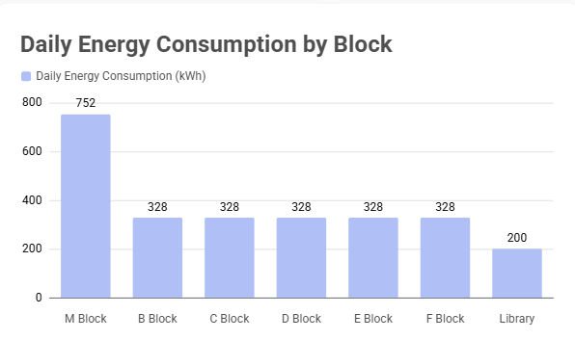
Key Insights
- M Block consumes by far the most energy (752 kWh/day), ~2.3x each of the other classroom blocks (328 kWh/day)
- Six classroom blocks (B, C, D, E, F, and one repeated value) share an equal consumption (328 kWh/day), indicating uniformity in those block loads
- Library is a clear outlier on the low end at 200 kWh/day despite longer usage hours

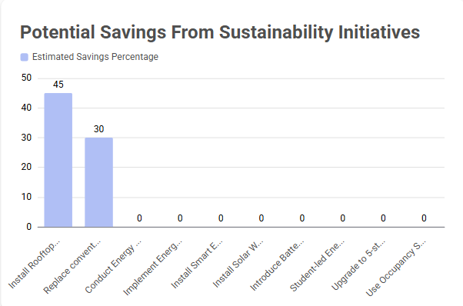
Key Insights
- Two initiatives dominate the estimated savings: rooftop solar (~45%) and LED replacement (~30%)
- All other listed initiatives show zero estimated savings in the data, highlighting either missing estimates or low-impact assumptions
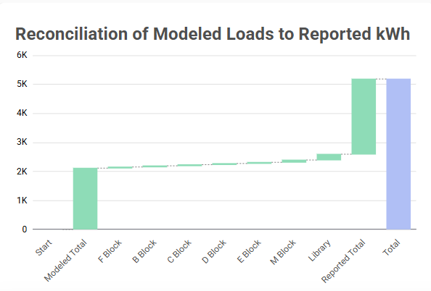
Key Insights
- Modeled total (2,112 kWh) is substantially lower than the reported total (2,592 kWh), leaving a reconciliation gap of 480 kWh explained by block-level additions
- The waterfall shows multiple equal small adjustments (40 kWh each for several blocks) plus larger adjustments for M Block (80 kWh) and Library (200 kWh), indicating concentrated discrepancies in those areas
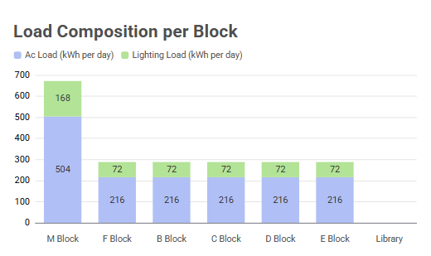
Key Insights
- AC load dominates total consumption in every classroom block (216 kWh/day lighting vs 72 kWh/day lighting), with AC ~3x lighting load
- M Block is a clear outlier with much higher AC (504 kWh) and lighting (168 kWh) totals than other blocks, mirroring its overall higher consumption

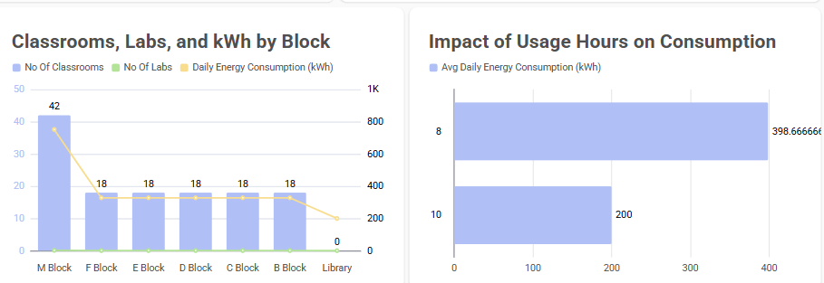
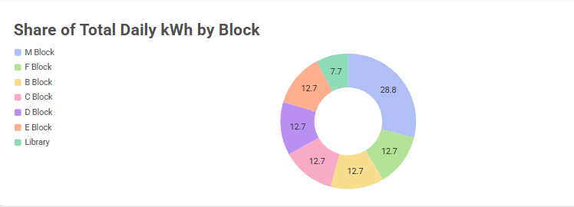
Initiative | Estimated Savings % | Estimated Daily kWh Savings
Install Rooftop Solar Panels on all Blocks | 50.0% | 1296
Replace conventional lights with LED lighting | 30.0% | 777.6
Install Smart Energy Meters for each block | 0.0% | 0
Use Occupancy Sensors in classrooms and labs | 0.0% | 0
Upgrade to 5-star rated inverter AC systems | 0.0% | 0
Implement Energy Monitoring Dashboard | 0.0% | 0
Install Solar Water Heating Systems | 0.0% | 0
Conduct Energy Audit every 6 months | 0.0% | 0
Introduce Battery Storage System for solar integration | 0.0% | 0
Student-led Energy Awareness Campaign | 0.0% | 0

Key Insights
- Install Rooftop Solar Panels (50% estimated savings, 1,296 kWh/day) and Replace conventional lights with LED (30%, 777.6 kWh/day) account for all quantified savings
- All other initiatives are recorded with 0% and 0 kWh/day savings, indicating no estimated impact or missing savings estimates for those measures

